

|  |  |
| --- | --- |
| Course Number and Name:  ME 747 | |
| Semester and Year:  Fall 2017 | Name of Lab Instructor:  Alireza Ebadi |
| Lab Section and Meeting Time:  Section 2B, Tuesday 2-5 pm | Report Type:  Internal Group Report |
| Title of Experiment:  Velocity and Position Sensors: LVT and LVDT Characterization, Parameter Identification | |
| Date Experiment Performed:  10/17/17 | Date Report Submitted:  10/31/17 |
| Names of Group Members:  Zhangxi Feng  Simon Popecki  Reilly Webb | Grader's Comments: |
| Grade: |

Table of Contents

Objectives 3

Executive Summary 3

Theory and Experimental Methods 4

Results and Discussion 10

Conclusions 22

References 24

Appendices 24

List of Figures

Figure 1: 1st Break Frequency Approximation. The larger time division data was used. 6

Figure 2: 2nd Break Frequency Approximation. The smaller time division data was used. 6

Figure 3: LVDT Diagram 8

Figure 4: DAQ 10

Figure 5: Plot of LVT signal 10

Figure 6: LVT measurement converted velocity and integrated 12

Figure 7: Damped portion of the foam 13

Figure 8: Coil 1 and coil 2 downward deflection 14

Figure 9: Coil 1 and coil 2 null output 14

Figure 10:Coil 1 and coil 2 upward output 15

Figure 11: Amplitude modulated coil outputs 16

Figure 12: Demodulated Signal 16

Figure 13: Controlled Masses 17

Figure 14: Controlled Deflections 18

Figure 15: Weight vs. Deflection of the beam 19

Figure 16: Theoretical Bode Diagram of the Low Pass Filter 20

Figure 17: Experimental frequency response 21

Figure 18: Theoretical Frequency Response 22

List of Tables

Table 1: Controlled mass loading and output voltage measurements 18

Table 2: Controlled deflections and output voltage measurements 18

# Objectives

The characteristics of a mass-spring-damper system were determined through the use of a linear velocity transducer (LVT) that produces a voltage proportional to the velocity of a magnetic core. Next, the properties of a linear variable differential transformer were investigated by calibration through weights and beam deflection. The effects of modulation and filtering were also observed. Experimental frequency response of the system was then determined using Lab View Signal Express.

# Executive Summary

# Theory and Experimental Methods

**Theory**

1. Linear Velocity Transducer

$$m=74.9 g$$

$$ζ=0.1130$$

$$T=0.0813\frac{s}{cyc}, ω_{d}=\frac{2π}{T}=77.3188\frac{rad}{s}$$

$$ω_{n}=\frac{ω_{d}}{\sqrt{1-ζ^{2}}}=\frac{2π}{T\sqrt{1-ζ^{2}}}=77.8171\frac{rad}{s}$$

$$k=ω_{n}^{2}*m=453.5567\frac{kg}{s^{2}}=453.5657\frac{N}{m}=31.1\frac{lb_{f}}{ft}=2.588\frac{lb_{f}}{in}$$

**The average force of impact** when the shaft hits the foam would be equal to the damping force of the foam, which is relative to its damping coefficient:

$$B=2*ζ*\frac{k}{ω_{n}}=1.3171\frac{N}{m/s}=0.09025\frac{lb_{f}}{ft/s}$$

Using damping force formula:

$$F_{avg}=B*v_{i}$$

Where $v_{i}$ is the velocity of the mass upon impact with the foam, using the first three minimum peaks in Figure 1 (since the first three falls are estimated to be free falls):

$$v_{i}=\left[-29.59, -16.03, -8.46\right] ft/sec$$

Which gives an average force:

* 1. And 2.2 LVDT System Characteristics and Calibration

The range of linearity of the LVDT can be found with the coefficient of determination

$$R^{2}=1-\frac{\sum{{\left(y-y_{fit}\right)}^{2}}}{\sum{{\left(x-\overline{x}\right)}^{2}}}$$

Both calibrations resulted in an $R^{2}$ of about 1, meaning that they are very linear.

Spring constant, k, was found through Hook’s law

$$k=\frac{F}{x}=166.5 lbf/in$$

In this case, this was determined through finding the slope of the fitted line to the weight to displacement calibration data.

Sensitivity was found in a similar fashion, using the slope of the voltage to deflection line

$$Sensitivity=\frac{V}{x}=2.96 V/in$$

The damping ratio can then be found from the raw data using the log decrement method on any two successive peaks

$$ζ=\frac{1}{\sqrt{1+(\frac{2π}{δ})^{2}}}=.0050 where δ=\frac{1}{n} ln⁡(\frac{x\left(t\right)}{x\left(t+nT\right)})$$

where $x(t)$ is the amplitude at time $t$, $T$ is the period, and $n$ is the number of positive successive peaks. The damped and undamped natural frequency can then be found as follows

$$ω_{d}=\frac{2π}{T}=191.500 rad/s$$

$$ω_{n}=\frac{2π}{T\sqrt{1-ζ^{2}}}=191.533 rad/s$$

Effective mass could then be calculated

$$M_{eff}=\frac{-k}{ω_{n}^{2}}=0.0045 kg$$

2.3 LVDT Frequency Response

The break frequencies were found by extrapolating a linear fit for the horizontal line for usable bandwidth in the magnitude plot. Then the intersection points with the sloped filtered magnitude lines were found such that the error with the actual curve is about 3 dB. The frequencies at these two points are the break frequencies. See Figure 1 and 2



Figure : 1st Break Frequency Approximation. The larger time division data was used.



Figure : 2nd Break Frequency Approximation. The smaller time division data was used.

The break frequency that were found in Hertz are

$$f_{b1}=308.3 Hz , f_{b2}=47485 Hz$$

The LVDT system follows the following transfer function

$$\frac{E_{o}(jω)}{E_{i}(jω)}=\frac{2R_{m}K_{m}xs/(R_{m}+2R_{s})R_{p}}{(\frac{L_{p}}{R_{p}}s+1)(\frac{2L_{o}}{R_{m}+2R_{s}}s+1)}$$

From the spec sheet:

$$R_{s}=408 Ω, { R}_{p}=162 Ω, R_{m}=1 MΩ$$

The transfer function is in standard form, so time constant relationships can be used with the s coefficients in the denominator. $R_{s}$ is the input impedance, $R_{s}$ is the output impedance, and $R_{m}$ is the measuring impedance

$$L_{p}=\frac{R_{p}}{2πf_{b1}}=0.0836 H$$

$$L_{o}=\frac{{(R}_{m}+2R_{s})}{4πf_{b2}}=1.6772 H$$

Usable bandwidth is between the break frequencies, 308 Hz – 47.5 kHz

The theoretical sensitivity for any frequency within this bandwidth is determined by taking the magnitude of the transfer function for that range.

$$Sensitivity={\left|\frac{E_{o}(jω)}{E_{i}(jω)}\right|}_{ω_{band}}=\frac{\sqrt{({\frac{2R_{m}K_{m}xω}{\left(R_{m}+R_{s}\right)R_{p}})}^{2}}}{\sqrt{(-{\frac{2L_{p}L_{o}ω^{2}}{R_{p}(R_{m}+2R_{s})}+1)}^{2}}+\sqrt{({ω(\frac{L_{p}}{R_{p}}+\frac{2L_{o}}{R_{m}+2R_{s}}))}^{2}}}$$

The sensitivity is defined from the bode plot as 0.0794 (-22 dB). Assuming x=0.1 in, the gain term $K_{m}$ is defined as follows

$$K_{m}=\frac{\left(R_{m}+R_{s}\right)R_{p}\sqrt{(.0794(\sqrt{(-{\frac{2L_{p}L_{o}ω^{2}}{R_{p}(R_{m}+2R_{s})}+1)}^{2}}+\sqrt{({ω(\frac{L_{p}}{R_{p}}+\frac{2L_{o}}{R_{m}+2R_{s}}))}^{2}}{))}^{2}}}{2R_{m}xω}=0.0372$$

The total gain for the transfer function (numerator coefficient) can be found from

$$Gain=\frac{2R_{m}K_{m}x}{R_{m}+2R_{s}R_{p}}=4.58e-05$$

**Experimental Methods**

1. **Linear Velocity Transducer**

The LVT system was hooked up to the oscilloscope such that the trigger position could record a significant change in velocity of the shaft. The shaft was then dropped about an inch, which caused it to bounce off the foam. The first few oscillations left the foam and returned to freefall, however it soon became in constant contact with the foam and the signal quickly decayed.

**2.1 LVDT Characteristics**



Figure : LVDT Diagram

The function generator was used to create an excitation voltage, which was a sin wave with an amplitude of 6V and a frequency of 2.5 kHz.

Next, both coil outputs were hooked up to the oscilloscope. The signals were investigated for a few different states: with the core at null, above null, and below null. The amplitude of the input voltage was then increased to 10 V, and a full wave demodulator was implemented. The signal was then “averaged” to get a single value that was proportional to displacement. This was made possible by a low-pass filter. Data was collected for the vibrating beam from both the demodulator and the filter output.

A FFT frequency plot was taken of the demodulated signal with the beam moving and not moving. The frequency scale was 4.9 – 5.1 kHz, with a time scale of 0.5 sec and 75K total data points.

2.2 LVDT System Calibration

The LVDT (figure 3) was calibrated first by weight. A plastic bucket of known weight was incrementally filled with various weights up to 500g. The corresponding filter output was recorded for each increment.

Next, the LVDT was calibrated using incrementing deflections from a micrometer set up on the free end of the beam. Each micrometer measurement corresponded to a filtered output. Finally, an under-damped 2nd order response was collected by flicking the beam and recording the signal.

2.3 LVDT Frequency Response

An experimental frequency response was collected from the LVDT system by using Lab View Signal Express and a DAQ. This was accomplished **by sending broadband noise through the input of the circuit to test the whole spectrum of frequency inputs. The input was connected to the NI DAQ (Figure 4) output terminals. Refer to “Using LabView for Frequency Responses” by M.H. deLeon [1] for a more in depth procedure.**

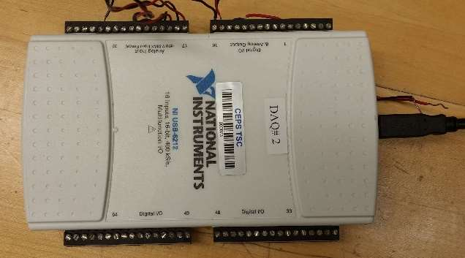

Figure : DAQ

# Results and Discussion

Part 1

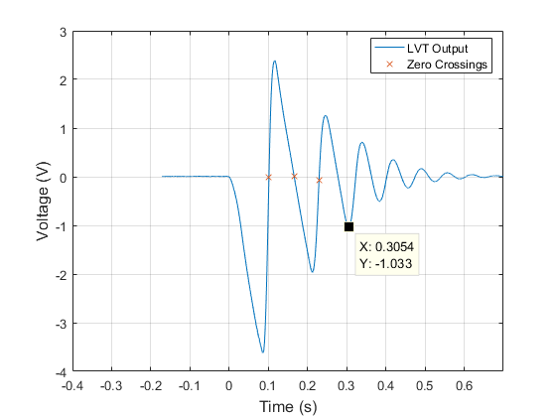

Figure : Plot of LVT signal

THE LINEAR VELOCITY TRANSDUCER

**The Motion Of Mass:**

During free fall, the slope of the velocity is linear, indicating there is a constant force acting on it in the negative direction – this is the force of gravity. The slope of the velocity measurements are negative, indicating by convention that the mass is falling. During initial impact with the foam, the velocity is still negative but begins to increase towards the positive direction, indicating the foam slows down the mass and slowly accelerates it at constant force (spring force) in the positive, upwards direction. When the velocity measurement crosses zero the first time at the leftmost labeled X point in Figure 5, the mass has reached the bottom of its trajectory inside the foam with maximum elastic potential energy and zero kinetic energy. Therefore, a short while after the X point the mass would bounce off the foam. At that moment, the mass would be travelling in the positive y direction and experience only experience the negative acceleration of gravity.

The Physical significance of the first three zero crossings are labeled by X in Figure 5. The first zero crossing is when the mass reached the lowest point inside the foam. The second zero crossing is when the mass reached the highest point after first bounce. The third zero crossing is when the mass reached the lowest point (with respect to each cycle) inside the foam. The first minimum voltage point is when the mass is about to hit the foam at a point where the gravitational potential energy is entirely converted to kinetic energy (maximum speed). The first maximum voltage point is when the mass reached the damped starting position where the undamped net displacement would be zero and velocity would be maximized.

After three free falls, the approximate time when the mass stopped bouncing off the foam is 0.15s. After that point, the negative displacement part of the velocity measurement appeared more like a second order damped output.

**Sensitivity of the Instrument:**

The MATLAB Polyfit linear regression function of the initial slope gives -47.251 V/s. With gravity, g = -386 in/sec2:

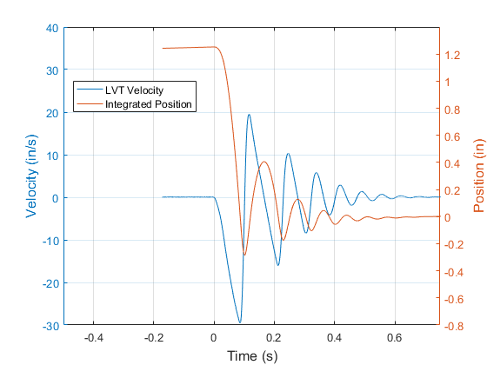

Figure : LVT measurement converted velocity and integrated

**Integrated Position and Velocity**

Figure 4, next page, shows the damped foam-mass system response. The circular peaks are used to determine the damping ratio and damped natural frequency. The spring constant is found using the equation: $k=ω_{n}^{2}*m$.

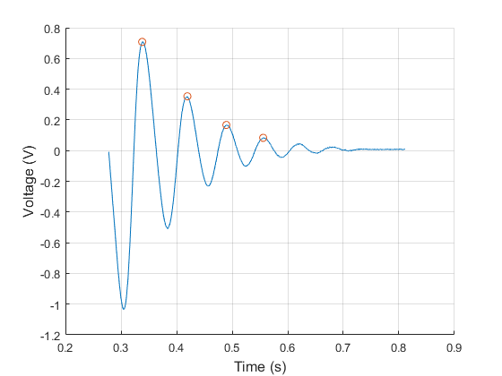

Figure : Damped portion of the foam

2.1

LVDT CHARACTERISTICS

Figure 8 below shows a plot of coil 1 and coil 2 before amplitude demodulation: 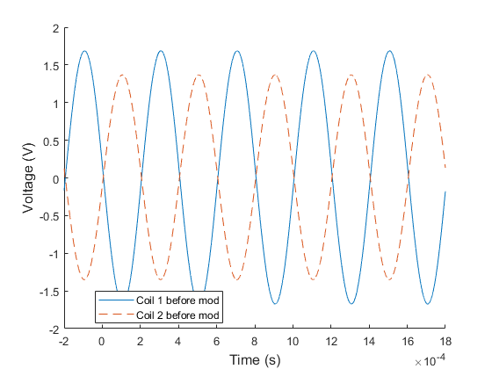

Figure : Coil 1 and coil 2 downward deflection

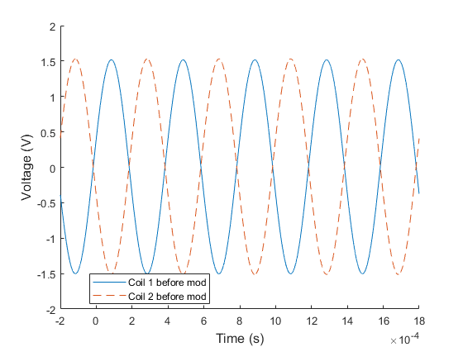

Figure : Coil 1 and coil 2 null output

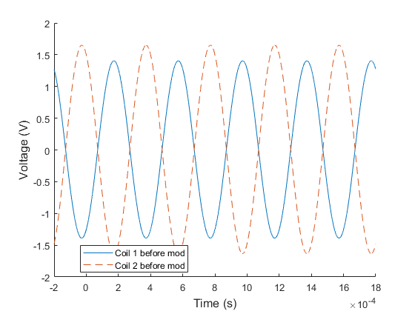

Figure :Coil 1 and coil 2 upward output

Figure 8 shows the coil outputs when beam is deflected downwards; Figure 9 shows the outputs when the beam is static (no deflection); and Figure 10 shows the outputs when the beam is deflected upwards. When beam is deflected downwards, coil 1 output has a higher amplitude than coil 2, suggesting the metal core is closer to coil 1 than coil 2, which facilitates higher magnetic flux and induces more current in coil 1’s circuit. Similarly, when the beam is deflected upwards, the core is closer to coil 2, resulting in a higher output amplitude. Conforming to this, when the beam is not deflected, both coils’ outputs have the same amplitude. This is characteristic behavior of an LVDT.

A phase-sensitive demodulator demodulated the modulated coil signals using diode Wheatstone bridges (eliminating negative portions of periodic signals). A modulated signal is one where the output is combined with a carrier wave to raise the signal to the detectable bandwidth range. Figure shows the demodulated result of the coil’s output signals from the LVDT’s excitation signal of 10 V sine wave at 2.5 kHz.

The diodes block currents in the opposite direction. Therefore, demodulation will result in signals all on one side, as shown by the almost M shaped signals for upwards and downwards deflections. The variations in the deflections as well as the no-deflection (null) state are results of the carrier frequency for the modulated signal.

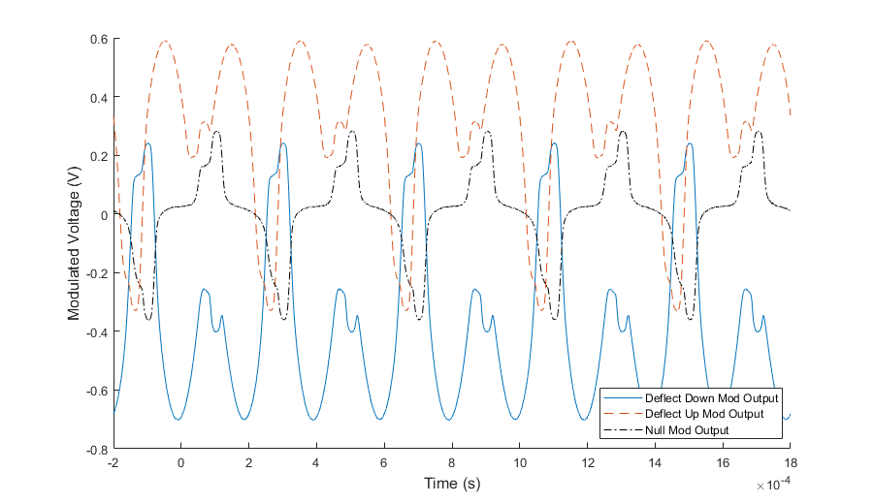

Figure : Amplitude modulated coil outputs

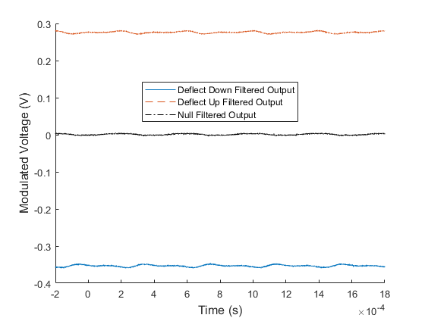

Figure : Demodulated Signal

The sensitive nature of the demodulation circuit calls for the need of a low-pass filter to remove the high frequency carrier wave in the output signal. This experiment used an RC circuit with a break frequency of 213 rad/s to act as the filter and the outputs are shown in Figure 12. It can be seen that when deflected upwards the output is positive, downwards is negative, and no deflection has an output of approximately zero.

2.2

Figure 13 and Figure 14 show the output voltage from the LVDT-beam setup at controlled loads, and controlled deflections. Both data are highly linear as shown with the linearly fitted lines. The coefficient of determination, $R^{2}$, value of the linear fits to the two sets of data are 0.9991 and 1.0 respectively. The coefficient equation is: $R^{2}=1-\frac{\sum{{\left(y-y_{fit}\right)}^{2}}}{\sum{{\left(x-\overline{x}\right)}^{2}}}$

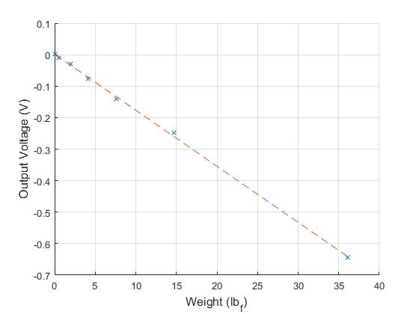

Figure : Controlled Masses

The high linearity suggests the slopes can be the sensitivity of the LVDT for loads and displacements. The original data of the two sets are shown in Table 1 and Table 2 below.

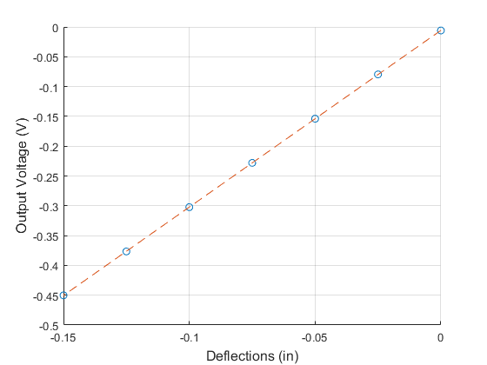

Figure : Controlled Deflections

Bucket mass = 7.65 g = 0.0169 lbm on Earth.

Table : Controlled mass loading and output voltage measurements

|  |  |
| --- | --- |
| Masses (lbm) [g]* | Voltage Output (mV) |
| 0 [0 g] | 1.335 |
| 0.0169 [7.65 g] | -10.475 |
| 0.0610 [27.65 g] | -28.59 |
| 0.1271 [57.65 g] | -76.09 |
| 0.2373 [107.65 g] | -140.55 |
| 0.4578 [207.65 g] | -247.43 |
| 1.1192 [507.65 g] | -643.76 |

* all values include the mass of the bucket, values in brackets are original measurements

Pounds mass is converted to pounds force by multiplying by 32.2 ft/s2.

Table : Controlled deflections and output voltage measurements

|  |  |
| --- | --- |
| Deflections (in) | Voltage Output (mV) |
| 0 | -5.9836 |
| -0.025 | -79.61 |
| -0.05 | -153.93 |
| -0.075 | -227.99 |
| -0.1 | -302.31 |
| -0.125 | -376.57 |
| -0.150 | -450.23 |

This linearity is only expected to hold true when the input signal frequency is within the bandwidth of the LVDT.

The spring constant, k has units of force/distance, or load/deflection, can be found after matching the voltage output response of weight to the voltage output response of the deflection.

The weight equivalent deflections are found to be:

|  |  |
| --- | --- |
| Weight (lbf) | Deflection (in) |
| 0 | 35.62 |
| 0.0169 | 14.32 |
| 0.0610 | 7.22 |
| 0.1271 | 3.67 |
| 0.2373 | 1.54 |
| 0.4578 | 0.12 |
| 1.1192 | -0.42 |

Polyfitting this data to a line gives a slope of 9166.5, suggesting the spring constant of the beam to be 166.5 lbf/in. The negative sign indicates weights are equivalent to negative deflections. The data and polyfitted line are shown in Figure 3:

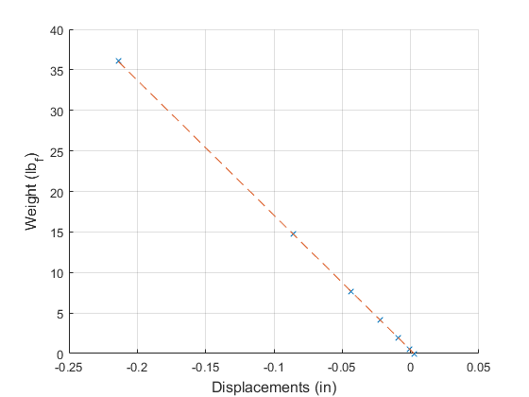

Figure : Weight vs. Deflection of the beam

The linearity of the data suggests the sensitivity of the LVDT for deflection to be equal to the slope of the voltage versus deflection fit line: 2.9643 V/in.

The damping ratio of the system was found to be .0050. The damped natural frequency was found to be 191.500 rad/s, and the undamped natural frequency (of the first mode of vibration) was found to be 191.533 rad/s. Finally, the effective mass of the system was calculated to be 0.0045 kg



Figure : Theoretical Bode Diagram of the Low Pass Filter

From the bode diagram of Low-pass filter, it can be seen that the LVDT output will only be affected by the filter when the input frequency is greater than approximately 200 rads/sec

**2.3 LVDT Frequency Response**



Figure : Experimental frequency response

Two break frequencies were extracted from the experimental bode response plot. $f_{b1}=308.3 Hz$ and $f_{b2}=47485 Hz$. This was done by linearly fitting the curves at both sides of the break, and marking the peak of the cusp as the frequency.

From these values, the inductances $L_{o}=1.6772 H$ and $L_{p}=0.0836 H$ could be found. The specification sheet was used to determine the impedances. Based on the bode plot, the usable bandwidth is between the break frequencies, 308 Hz – 47.5 kHz.

The theoretical sensitivity for any frequency within this bandwidth is determined by taking the magnitude of the transfer function for that range. The sensitivity is defined from the bode plot as 0.0794, or -22 dB. Assuming x=0.1 in, the gain term $K_{m}$ is then equal to 0.0372.



Figure : Theoretical Frequency Response

The theoretical bode plot in figure 18 matches the experimental bode plot relatively closely. The sensitivity for both is very close at around -22 dB, as well as the locations of the break frequencies (when both converted to rads/sec).

The core of the LVDT also has a resonant frequency that can add noise to the output signal. This resonant frequency can be an issue for the filter while the core is moving or force is applied to it. The filter also puts a ceiling on how high the input frequency can be while still giving a useful output.

If the input frequency gets below the first break frequency, the LVDT will filter out the signal and it won’t work.

# Conclusions

Jesse:

Simon:

Simon Popecki:

The Linear Velocity Transducer used in this lab had a sensitivity of 2.96 Volts per inch, making it sensitive enough to be useful in most dynamic measurement scenarios under an inch. A major benefit of the LVT system is the lack of input voltage required – the coil is able to provide its own power output directly to an op-amp, reducing the complexity of the metrological system.

Linear Varying Differential Transformers provide the ability to measure under static conditions, at the expense of added complexity – there is a required input of a periodic alternating current of a specific frequency which may not be available or easily set up in some applications outside of a lab, nor may the diode rectifier bridge be available. LVDT systems have a bandwidth – a limited frequency range of measurement capability. The larger the bandwidth, the lower the resolution of the sensor. The bandwidth of the LVDT system used in this lab was roughly 47 kHz. The mass of the core in an LVDT must be considered along with the electrical properties when applied to a moving system – the core may have enough weight to impact measurements.

Reilly:

For the most part, the gap between theoretical and experimental results remained low throughout this lab. This could be seen through looking at the bode plots in section 2.3.

This lab did a good job of demonstrating the pros and cons of each sensor. One big perk of the LVT was that it did not require an excitation voltage. However, the signal must be integrated if you want to find the position of the shaft, and that opens up more chances for error and uncertainty.

If this experiment were to be repeated, I would measure the true inductance of the LVDT. These values would be useful in checking our analysis techniques and calculations without making the analysis less challenging.

# References

[1] DeLeon, M H. “Using LabView for Frequency Responses.” 3 Sept. 2014.

# Appendices

**StatementOfSharedEffort.pdf**